**National University of Computer and Emerging Sciences**



**Lab Manual 03**

**Operating Systems**

**Topic: System Calls**

Department of Computer Science

FAST-NU, Lahore, Pakistan

**System Calls**

“In computing, a system call is the programmatic way in which a computer program requests a service from the kernel of the operating system it is executed on. A system call is a way for programs to interact with the operating system.”

* System Calls provides the **Interface** between a process and the Operating System.



These calls are generally available as Assembly language instruction.

* System Calls can also be **made directly** through High Level Language programs for certain systems.
* UNIX System calls can be invoked directly from a **C or C++ program**.

**Services Provided by System Calls:**

Services provided by system calls include the following:

* Process creation and management
* Main memory management
* File Access, Directory and File system management
* Device handling(I/O)
* Protection
* Networking, etc.

**Types of System Calls:**

There are 5 different categories of system calls

1. Process control
2. File management
3. Device management
4. Information maintenance
5. Communication

Unix and Windows have different system calls as can be seen from the table below

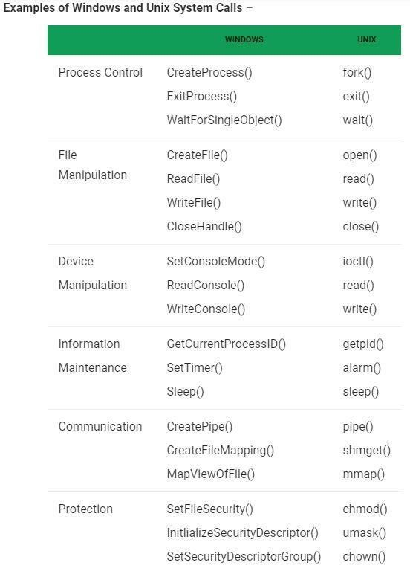

Reference –http://www.cs.columbia.edu/~jae/4118/L02-intro2-osc-ch2.pdf

# Fork ()

“Fork system call is used for creating a new process, which is called child process, which runs concurrently with the process that makes the fork() call (parent process)”

* After a new child process is created, both processes will execute the next instruction following the fork() system call.
* A child process uses the same pc(program counter), same CPU registers, same open files which use in the parent process.

|  |  |
| --- | --- |
| Syntax: | fork(); |

It takes no parameters but returns an integer value.

## Code

|  |
| --- |
| #include <stdio.h>  #include <sys/types.h> #include <unistd.h> int main()  {  printf("Welcome to my Program\n");  // make a new process which run same program after this instruction fork();  printf("Hello world!\n");  return 0;  } |

## Output

Welcome to my Program Hello world!

Hello world!

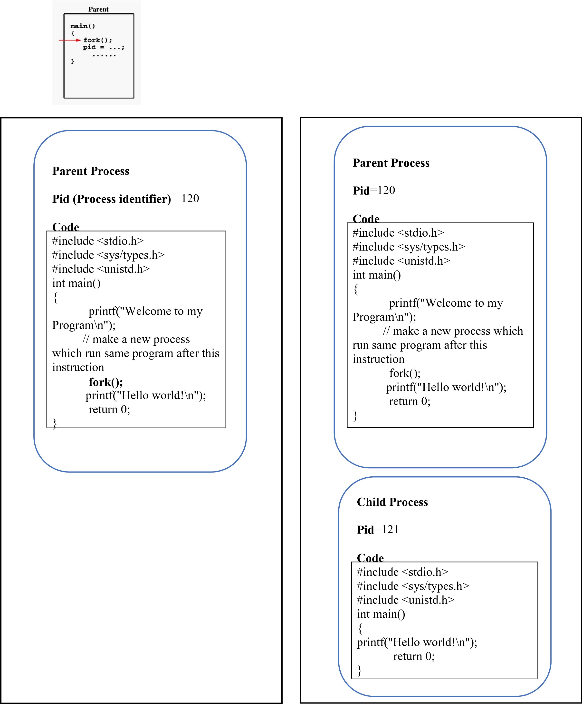

## Program Before Fork Program After Fork

**How to differentiate between a Parent and Child during execution?**

Below are different values returned by fork():

* **Negative Value:** creation of a child process was unsuccessful.
* **Zero:** Returned to the newly created child process.
* **Positive value/integer:** Returned to parent or caller. The value contains process ID of newly created child process.

## Code

|  |
| --- |
| #include <stdio.h>  #include <sys/types.h> #include <unistd.h> int main()  { pid_t a= fork(); if (a==0)  {  printf("\nHello world!, I am child");  } else if (a>0) { printf("\nHello world!, I am Parent");  } else{ printf("\nBye Bye world!, Error creating child");  } return 0;  } |

## Output

Hello world!, I am Parent

Hello world!, I am Child

**Note: Order of parent and child execution can vary unless controlled**

## Some more useful System Calls wait ()

A call to wait() blocks the calling process until one of its child processes exits or a signal is received. After child process terminates, parent continues its execution after **wait** system-call. 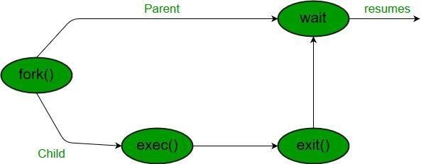 **exit()**

This call terminates the process and returns the process ID to the parent.

|  |
| --- |
| / C program to demonstrate working of wait()  #include<stdio.h>  #include<stdlib.h>  #include<unistd.h>  #include<sys/wait.h> #include<sys/types.h>  int main()  {  pid_t p, cpid;  printf("main id %d\n",getpid()); printf("before fork\n"); p=fork(); if(p==0)  { printf("I am child having id %d\n",getpid()); printf("My parent's id is %d\n",getppid()); exit(0);  }  else if(p>0)  {  cpid = wait(NULL);  printf("My child's id is %d\n",p);  printf("I am parent having id %d\n",getpid());  } else {  printf("ERROR");  }  printf("Your quiz is expected in next class\n"); } |

|  |
| --- |
| **Output** |
| main id 72 before fork  I am child having id 73  My parent's id is 72  My child's id is 73 I am parent having id 72  Your quiz is expected in next class |

**Using getppid() and getpid() to get ID’s of parent and the process itself.**

|  |  |
| --- | --- |
| getpid() | Whenever this function is called in a process, it returns the ID of that  particular process |
| getppid() | When this function is called in a process it returns the ID of that process’s parent. |

**Task 1: Fork ( ) (Estimated Time: 15 mins)**

* write a program to accept thhe return value of fork and print it on the screen.
* Write a program to declare a variable "a" and set it to 10.

**Task 2: Fork ( ) (Estimated Time: 15 mins)**

* Create a C program that takes an integer array of 10 values from the user in parent process through command line arguments.
* The program then creates a child process, and this Child sorts the array in ascending order and displays it on the screen.
* The child also prints its own ID before terminating.

**Task 3: Fork ( ) and wait ( ) System Call (Estimated Time: 30 mins)**

* Create a C program that takes an integer array of 10 values from the user in parent process through command line arguments.
* Create 2 child processes such that:
  + Child 1 prints its own and its parent’s ID on screen.
  + Then it sorts the array in **ascending order** and displays it on the screen. o Child 2 prints its own and its parent’s ID on screen.
  + Then it sorts the array in **descending order** and displays it on the screen.
* Except input and child-process creation no work should be done by the parent and parent **should terminate** **after** child process have terminated and also prints its **own and parent’s ID**.

**Example**

gcc main.c –o main ./main

5 4 6 9 8 7 1 2 3 5

I am Child 1 (with ID = 120 and Parent’s ID = 115): 1 2 3 4 5 5 6 7 8 9

I am Child 2 (with ID = 121 and Parent’s ID = 115): 9 8 7 6 5 5 4 3 2 1 Parent Process terminating and my ID = 115 and parent’s ID = 100